File Handling in PHP
When we develop a web application using PHP, quite often we need to work with external files, like reading data from a file or maybe writing user data into file etc. So it's important to know how files are handled while working on any web application.

File Handling Operations
File handling starts with creating a file, reading its content, writing into a file to appending data into an existing file and finally closing the file. Php provides pre-defined functions for all these operations, so let's start by knowing these functions.
- Create a File: fopen()
- Open a File: fopen()
- Read a File: fread()
- Write to a File: fwrite()
- Append to a File: fwrite()
- Close a File: fclose()
- Delete a File: unlink()
You must be wondering that why we have specified same functions for multiple file operations, well, that is because just by changing one or more arguments, same function can be used to perform multiple operations on file.
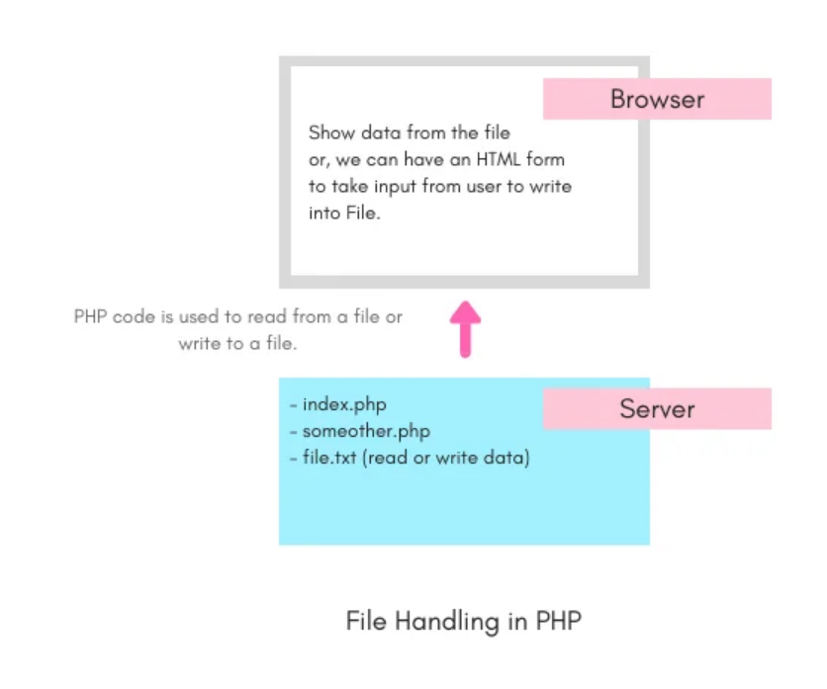

Uses of File in Applications
Following are some of the practical use cases where we need files in our web applications.
- Oftenly data is stored in for of JSON files, amd Php code has to read the file and then display the data on web page.
- In some simple applications, no database is used, rather data is stored in files.
- In some web applications, you may have to prepare a file for user to download, in that case PHP code will create a file, write data in it and then allow the user to download it.
Create, Open and Close a File in PHP
To create a new file or to open an existing file, we use the fopen() function provided by PHP and to close a file resource fclose() function is used.

Create a File with PHP
When we use the function fopen() to open a file which doesn't exist then that file gets created.
Let's take an example,
$myfile = 'file.txt';
//opens the file.txt file or implicitly creates the file
$handle = fopen($myfile, 'w') or die('Cannot open file: '.$myfile);

fopen() function takes the filename as the first argument and the second argument represents the mode in which the file will be opened.

Open a File with PHP
To open a file, the same fopen() function is used. There can be many reasons behind opening a file, like reading content of the file, writing new content to a file or appending additional content to the already existing content in the file.
Let's take a simple example, and then we will talk about the different modes in which a file can be opened.
$myfile = 'file.txt';
//opens the file.txt file
$handle = fopen($myfile, 'w') or die('Cannot open file: '.$myfile);
Again, fopen() function takes two mandatory arguments, one is the filename and the second one represents the mode.
Following are the different modes along with the literal which should be passed as argument in the fopen() function.
Mode | String Literal | Description
Write mode | w | If the file exists then it is opened to allow write operation in it and if it doesn't exist, then a new file is created. In this mode all the existing data in file gets erased.
Read mode | r | File is opened in read mode with the file pointer starting from the beginning of the file.
Append mode | a | File is opened in write mode where existing content of the file is note erased. The new content in added after the existing content.
Create Write-only file | x | A new file is created with write-only access. If the file already exists then error is returned.
Apart from the mode specified above, we can add + along with the string literals to allow both read and write(default) operation for a given mode.
For example, r+ mode opens file for read and write both. w+, a+ allow read operation on the file along with the default write and append operations respectively.
Technically, file is not opened, fopen() binds the resource(file) to a stream, which can then be used to read from the file or write data to the file.
Also, the filename should be fully qualified name along with relative path if the file is a local file. The filename can also be a URL to specify a remote fiel's path. In that case, once PHP realise that the file path is not local, it will check for the value of allow_url_fopen property in the php.ini(PHP's configuration file). If it is false, PHP will print a warning and fopen() call will fail.

Close a File with PHP
It is good practice to close a file resource after using it. In PHP fclose() function is used to close a file resourcse. It takes the file name as argument or the variable holding the file resource pointer as argument. Let's take an example:
$myfile = 'file.txt';
//opens the file.txt file or implicitly creates the file
$handle = fopen($myfile, 'w') or die('Cannot open file: '.$myfile);
// closing a file
fclose($handle);

